Daily AQI values of CAAQM Stations in Bengaluru (August – 2021)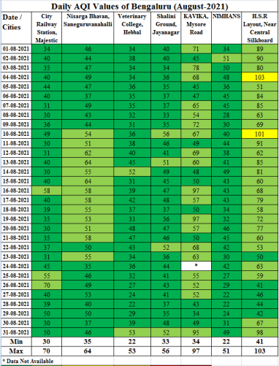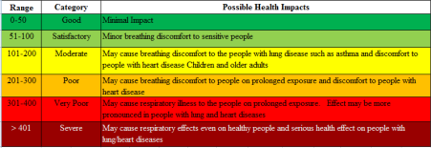
AQI Trend Bengaluru, August 2021
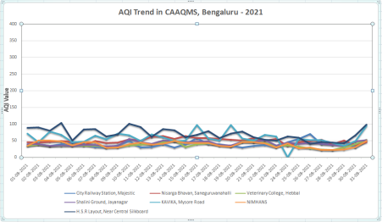
Hebbal, Jayanagar, KAVIKA, NIMHANS, Silkboard, Nisarga Bhavan (Basaveshwaranagar), City Railway Station(CRS)
